* **Super Admin Dashboard: -**

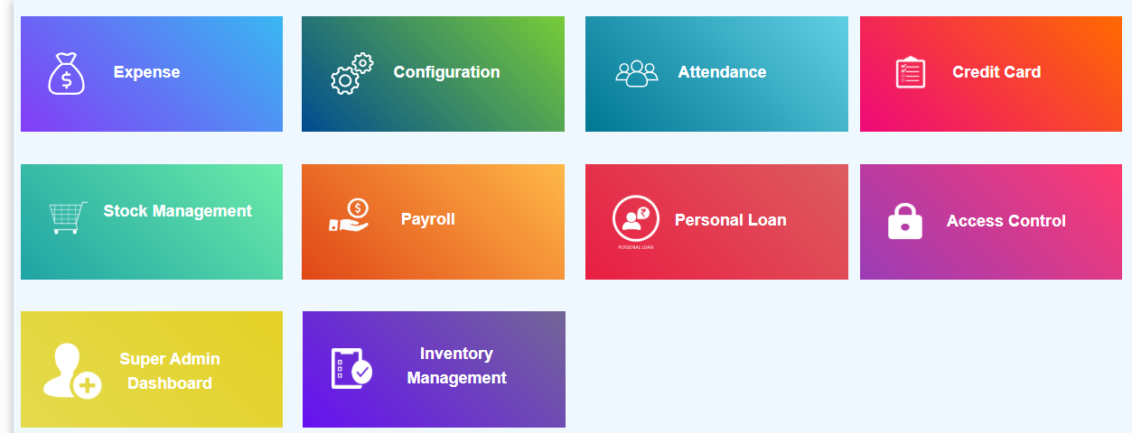

* Super admin dashboard is only visible to Super admin.
* Click on super admin dashboard

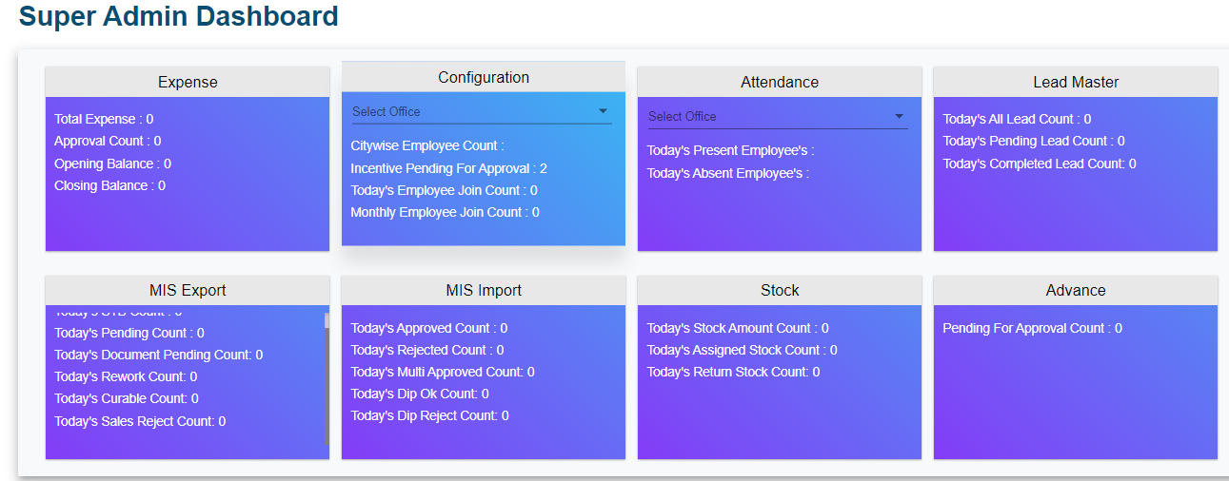

* Super admin dashboard contains different blocks mentioned below:
* Expense
* Configuration
* Attendance
* Lead Master
* MIS Export
* MIS Import
* Stock
* Advance

1. **Expense: -**

* If you click on Expense, it redirects you to expense master module.
* Expense block contains total expense, approval count, opening balance, closing balance.
* Total expense- Todays total expense amount is displayed here
* Approval Count- It is count of expenses pending for approval
* Opening Balance- Whatever amount we added by using add opening balance displayed here.
* Closing Balance- Total spending amount from today’s opening balance

1. **Configuration-**

* If you click on configuration it redirects you to Employee Master
* Configuration block contains select office option. First you have to select office, then it displays below information of that selected office.
* Citywise Employee Count, Incentive Pending for approval, Today’s Employee Join Count, Monthly Employee Join Count.
* Citywise Employee Count- It display total number of employees of selected office
* Incentive Pending for approval- It display number of incentives pending for approval from all offices.
* Today’s Employee Join Count- Number of employees join today of that selected office.
* Monthly Employee Join Count- Number of employees join in current month.

1. **Attendance-**

* If you click on Attendance it redirects you to Daily attendance module.
* In Attendance block, Click on Select office
* Select office from dropdown menu
* It will display, number of employees present today and number of employees absent today.

1. **Lead Master-**

* If you click on lead master, it redirects you to lead sheet module of credit card.
* Lead master block contains Today's All Lead Count, Today's Pending Lead Count, Today's Completed Lead Count

1. **MIS Export-**

* If you click on MIS Export block, it redirects you to Credit card MIS export
* MIS export block contains below points

###### Today's STB Count: Todays number of leads having STB status

###### Today's Pending Count: Todays number of leads whose status is pending

###### Today's Document Pending Count: Todays number of leads whose status is Document pending

###### Today's Rework Count: Todays number of leads whose status is Rework

###### Today's Curable Count: Todays number of leads whose status is Curable.

###### Today's Sales Reject Count: Todays number of leads whose status is Sales Reject.

1. **MIS Import-**

* If you click on MIS import, it redirects you to Credit card MIS import>Master Table
* MIS import block contains below points of Credit Card-

###### Approved Count: Number of todays approved leads

###### Today's Rejected Count: Number of todays rejected leads

###### Today's Multi Approved Count: Number of leads whose status is Multi Approved.

###### Today's Dip Ok Count: Number of leads whose status is Dip Ok.

###### Today's Dip Reject Count: Number of leads whose status is Dip Reject.

###### Stock-

###### If you click on Stock it redirects you to stock report

###### Stock block contains following points-

###### Today's Stock Amount Count: Total amount of todays added stock

###### Today's Assigned Stock Count: Total amount of todays assigned stock to employee

###### Today's Return Stock Count: Total amount of today’s return stock from customer

###### Advance-

###### If you click on advance, it redirects you to Advance Report

###### This block contains Pending For Approval Count: It is count of advances added by employees need to take approval from super admin.